Enhancing Cloud Data Security Using Paillier Homomorphic Encryption Algorithm
Mohammed Farhaan Ahmed  B.E. Computer Science Student,  Dept. of Computer Science,  Lords Institute of Engineering and Technology,  Hyderabad, INDIA | Mohammed Abdul Kareem  B.E. Computer Science Student,  Dept. of Computer Science,  Lords Institute of Engineering and Technology,  Hyderabad, INDIA

Mohammed Imad Uddin  B.E. Computer Science Student,  Dept. of Computer Science,  Lords Institute of Engineering and Technology,  Hyderabad, INDIA | Mrs. B Nagalakshmi  Assistant Professor (Internal Guide),  Dept. of Information Technology,  Lords Institute of Engineering and Technology,  Hyderabad, INDIA

Abstract: Cloud computing provides essential scalable storage, but storing sensitive information on third-party servers introduces significant data leakage and privacy vulnerabilities. This paper presents a secure cloud data storage and privacy-preserving framework utilizing a hybrid cryptographic architecture. The system combines the Advanced Encryption Standard (AES-128-CBC) for highly efficient bulk file encryption with the Paillier Homomorphic Encryption Algorithm (PHEA) for secure key verification and privacy-preserving numerical aggregations. Data preprocessing involves dynamic PKCS#7 padding and client-side encryption prior to database persistence. The proposed PHEA achieves an encryption time of 19 ms and a decryption time of 35 ms for 5,000-byte payloads. Deployed as a Django web application, the framework incorporates strict administrative controls, user account state verification (Pending, Verified, Rejected, Blocked), and role-based decryption request approvals. Results confirm that the hybrid architecture effectively ensures end-to-end data confidentiality and provides robust access control without exposing plaintext data.
Keywords: Cloud Data Security, Paillier Homomorphic Encryption Algorithm, AES-128-CBC, Hybrid Encryption, Access Control, Decryption Request Approval, Django Web Architecture.
—————————— ❖ ——————————

I. INTRODUCTION
The rapid transition from on-premises data centers to distributed cloud services has heightened security requirements around data custody and privacy. While cloud providers deliver high availability and elastic scalability, delegating data management to commercial hosts introduces vulnerabilities concerning data confidentiality and unauthorized inspection.
Traditional cryptographic techniques, such as symmetric AES, provide rapid encryption suitable for bulk files, but they do not support direct algebraic manipulation of encrypted payloads. This fundamental limitation means data must be decrypted back into plaintext before any meaningful computation can occur, exposing raw data to potential memory scraping or insider threats within the cloud host.
To address this, homomorphic encryption allows specific mathematical operations to be executed directly on ciphertexts. The Paillier Homomorphic Encryption Algorithm (PHEA) provides an additive homomorphism property, enabling intermediate mathematical aggregations to occur on encrypted data. To leverage the computational efficiency of AES and the privacy-preserving features of PHEA, a hybrid framework implemented within a Python/Django architecture is proposed, combining bulk symmetric encryption with layered session management and administrative request controls.
The remainder of this paper is organized as follows: Section II reviews related literature. Section III describes the methodology. Section IV outlines the proposed framework. Section V covers implementation. Section VI discusses results. Section VII concludes with future directions.

II. LITERATURE REVIEW
Junior et al. (2025) conducted a comprehensive survey on homomorphic encryption in cloud privacy, evaluating execution time and communication overhead across schemes, though without delivering a deployed architecture [2].
Kim and Pham (2026) proposed a secure cloud banking data-processing architecture integrating Homomorphic Encryption (HE), Zero-Knowledge Proofs (ZKP), and Oblivious RAM (ORAM). Their model demonstrated strong privacy preservation during server-side execution but incurred significant computational overhead due to recursive protocols and was tailored exclusively to banking workflows [1].
Chan et al. (2025) introduced a hybrid homomorphic framework (HHEML) coupling symmetric cryptography with fully homomorphic encryption, but focused predominantly on machine learning inference on specialized edge hardware rather than structured cloud data storage [3].
Serengil and Ozpinar (2025) analyzed partially homomorphic cryptosystems (including Paillier) for vector similarity computations in recommendation systems, yet did not address broader storage requirements like role-based access control [4].
Reyana et al. (2023) investigated pre-storage encryption standards, demonstrating the critical need to encrypt data client-side before cloud persistence occurs. However, their work analyzed symmetric pipelines without incorporating homomorphic computation capabilities or an administrative decryption-request approval process [6].
The reviewed literature consistently reveals a gap: most homomorphic encryption solutions incur excessive computational overhead or focus strictly on computations rather than file storage, and existing pre-storage encryption frameworks lack a unified, deployable architecture with strict administrative decryption-approval pipelines. The proposed system addresses these gaps through a hybrid AES-Paillier architecture.
III. METHODOLOGY
The proposed methodology adopts a multi-tier web application architecture that strictly separates client interaction, core business logic, cryptographic processing, and persistent database storage.
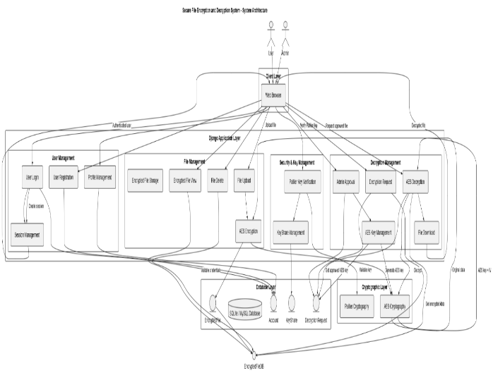
Fig. 1 System Architecture of the Secure File Encryption and Decryption System
A. Data Ingestion and Pre-Storage Isolation (AES-128-CBC)
To ensure high-throughput processing with minimal computational overhead, arbitrary files and large data streams are secured using symmetric cryptography. Raw input files are parsed as contiguous byte sequences. The system dynamically generates a cryptographically secure 128-bit key and a 16-byte Initialization Vector (IV) in volatile memory. Plaintext bytes are padded to 16-byte block boundaries according to PKCS#7 conventions and encrypted using AES in Cipher Block Chaining (CBC) mode. The resulting ciphertext is concatenated with the IV (Payload = IV + Ciphertext) and persisted as a BinaryField in the EncryptedFile model. Original plaintext is never stored in the database.
B. Paillier Homomorphic Key & Computation Framework The Paillier cryptosystem provides public-key encryption with additive homomorphic capabilities, enabling key-share validation and secure numerical aggregation on untrusted hosts without decryption. Key generation involves selecting two large independent prime numbers, p and q, where gcd(pq, (p-1)(q-1)) = 1.
To upload and encrypt a file, verified users must navigate to a verification portal and submit their assigned Paillier private key share. The backend validates this submission against the KeyShare model; upon a successful match, an ephemeral session flag (allow_encrypt = True) is activated, unlocking file upload permissions for that session. Following the encryption of a file, this permission is immediately revoked to prevent replay exploits.
Furthermore, the additive homomorphic property allows the cloud platform to perform mathematical summations across encrypted numerical parameters without access to the underlying private keys. Given two ciphertexts $c_{1}=E\left(m_{1}\right)$ and $c_{2}=E\left(m_{2}\right)$, their modular product yields the encrypted sum of the plaintexts: $c_{sum}=\left(c_{1}⋅c_{2}\right) \operatorname{mod}{n^{2}} =E\left(m_{1}+m_{2}\right)$.
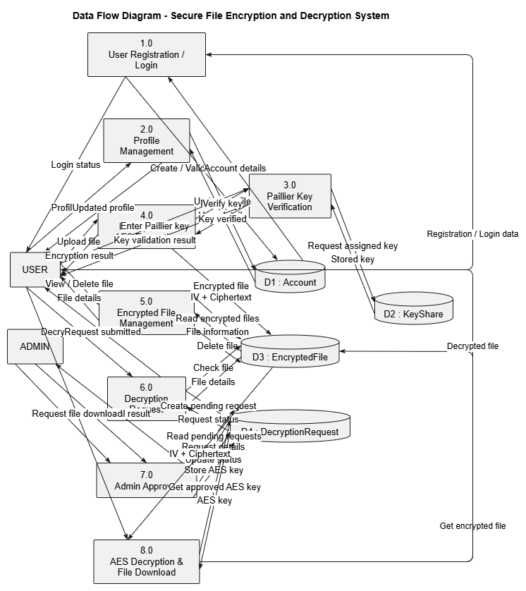
Fig. 2. Sequence Diagram for File Upload and Encryption Workflow.
C. Decryption Approval Workflow
The framework incorporates a strict petition-and-approval model to govern data access. Users cannot directly decrypt stored files. When an asset is required, the user submits a formal decryption request, creating a database record with a 'Pending' status. The system administrator inspects pending requests via a centralized dashboard and grants authorization. Upon approval, the system associates the required AES decryption key with the request record and transitions its state to 'Approved'. Only after this administrative authorization can the file owner trigger the download operation, during which the system extracts the 16-byte IV, executes AES-128-CBC unpadding routines, and restores the original plaintext bytes.
IV. PROPOSED FRAMEWORK
The proposed system overcomes existing limitations by simultaneously addressing file storage encryption and numerical aggregation within a unified pipeline.
Stage 1 — User Validation: A client registers an account, which is assigned a 'Pending' status. An administrator must upgrade the status to 'Verified' to allow system login.
Stage2 — Key Provisioning: The administrator generates and provisions a Paillier public/private key pair and an initial symmetric key share for the verified user.
Stage 3 — Key-Share Verification: The user submits their assigned Paillier private key share to activate the single-use session flag (allow_encrypt = True).
Stage 4 — File Encryption: The user uploads a file. The system generates a dynamic 128-bit AES key and a 16-byte IV, pads the plaintext via PKCS#7, and performs AES-128-CBC encryption.
Stage 5 — Cloud Persistence: The IV and ciphertext are concatenated and stored in the database. The session flag is reset.Stage
6 — Decryption Petition: The user submits a formal request to decrypt a stored file.Stage
7 — Administrator Approval: The administrator reviews the pending request, binds the corresponding AES decryption key, and approves the request.
Stage 8 — Plaintext Delivery: The user initiates the download. The system extracts the IV, decrypts the payload, strips the padding, and delivers the restored plaintext alongside comparative encrypted hex dumps.
V. IMPLEMENTATION
A. Technologies Used
Python 3.8+ serves as the core programming runtime, handling cryptographic arithmetic and binary manipulation. The Django Web Framework (v3.2+/v4.0+) provides the Model-View-Template (MVT) architecture, ORM, and secure session abstractions. PyCryptodome provides hardware-accelerated AES-128 block cipher implementations in CBC mode. Python-Paillier (phe) supplies optimized routines for homomorphic operations. SQLite is used for persistent relational database storage. HTML5, CSS3, Bootstrap, and JavaScript power the frontend presentation layer.
B. Hardware Requirements
Minimum specifications: Processor: Intel Core i3/i5 (2.0 GHz or higher); RAM: 4 GB (8 GB recommended); Storage: 20 GB available space; OS: Windows 10/11, Ubuntu Linux (18.04 LTS+), or macOS.
C. Ethical Considerations
The system protects user authentication credentials using cryptographically secure password hashing (PBKDF2). No plaintext file contents are exposed to unauthorized actors, and the database stores only initialization vectors and ciphertext.
VI. RESULTS AND DISCUSSION
The system was evaluated across two primary dimensions: cryptographic performance (latency and overhead) and security workflow integrity (access control and administrative validation).
A. Cryptographic Performance
Table 1 presents the performance benchmarks for the hybrid cryptographic architecture evaluated on a standard payload.

Table 1. Overall Cryptographic Performance Benchmarks
Metric | Payload | Runtime
Encryption Time | 5,000 bytes | 19 ms
Decryption Time | 5,000 bytes | 35 ms
The experimental evaluation confirms that the hybrid cryptographic architecture provides strong data confidentiality while maintaining practical computational efficiency. The 19 ms encryption latency confirms that the computational overhead of homomorphic key validation does not severely degrade bulk file handling efficiency.
B. Workflow Integrity and Security Validation
The operational integrity of the system was evaluated against 40 comprehensive test cases covering authentication, administrative controls, key verification, file encryption, data management, and decryption approval workflows.
Table 2. Security and Workflow Validation Results
Modules | Status
Key Verification | Pass
File Encryption | Pass
Decryption Approvals | Pass
The system successfully passed all 40 functional and security test cases. Direct database inspection during testing confirmed that storing files as concatenated IV + Ciphertext binary payloads prevents unauthorized data exposure. Testing validated that restricting file upload privileges behind a single-use session flag, combined with mandatory administrative decryption approvals, prevents unauthorized file modifications.
C. System Interface and Execution
The Django-based GUI successfully generates administrative dashboards for tracking Paillier key distributions and pending decryption requests, alongside client-facing portals for key-share verification and encrypted hex previews. Encrypted files are exposed to standard interfaces only as 60-byte hexadecimal previews.
The implementation of the allow_encrypt session flag and the multi-party decryption approval workflow successfully addresses the literature gap regarding strict pre-storage data governance. By stripping automated decryption rights from the end-user and requiring an administrator to bind the AES key to the request, the system prevents credential theft from resulting in immediate data exposure.
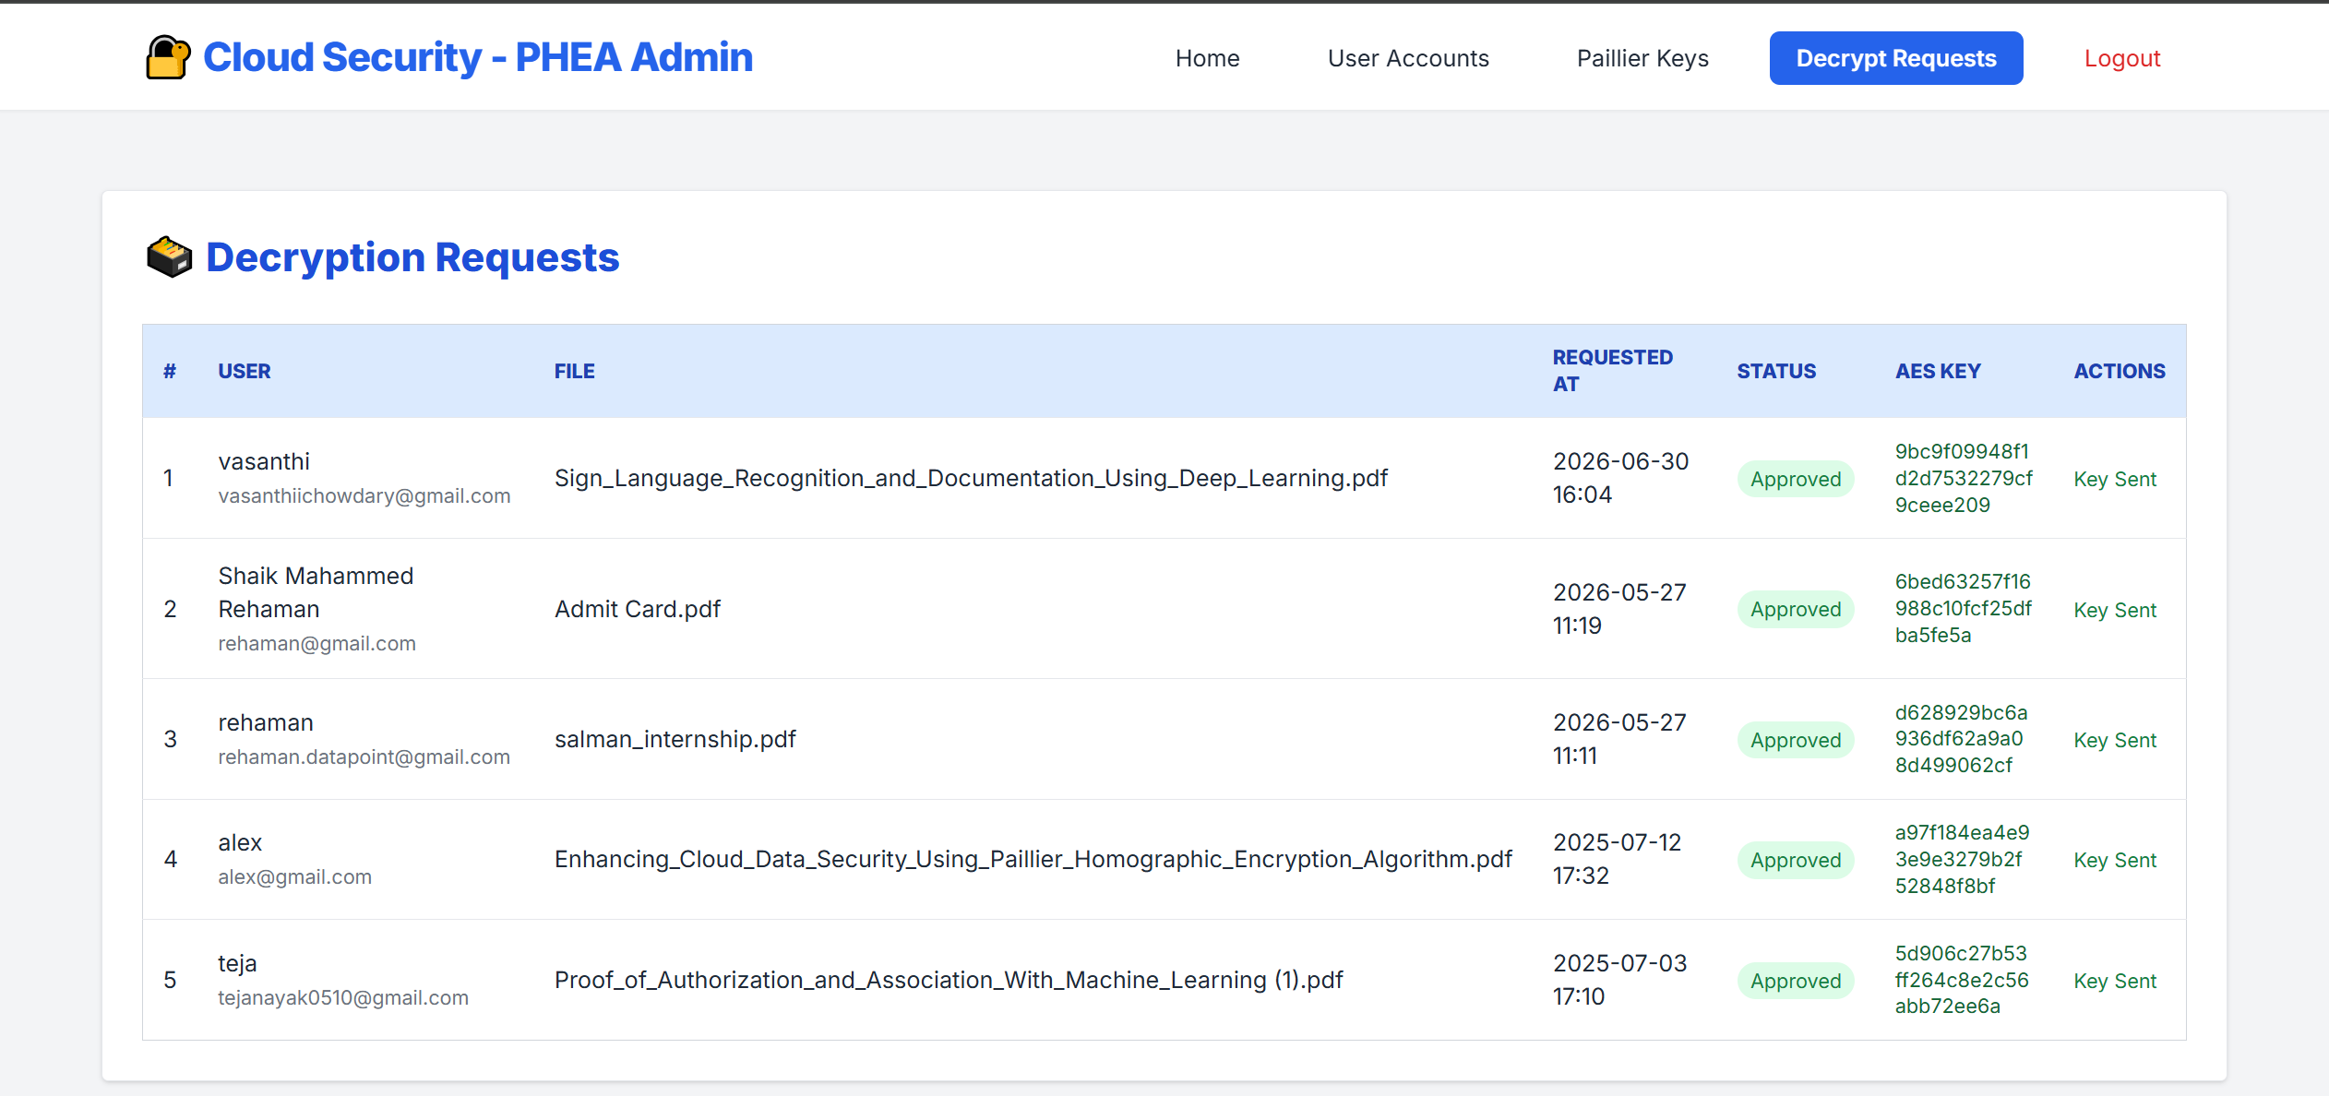Fig. 3. Administrator Decryption Request Approval Queue.

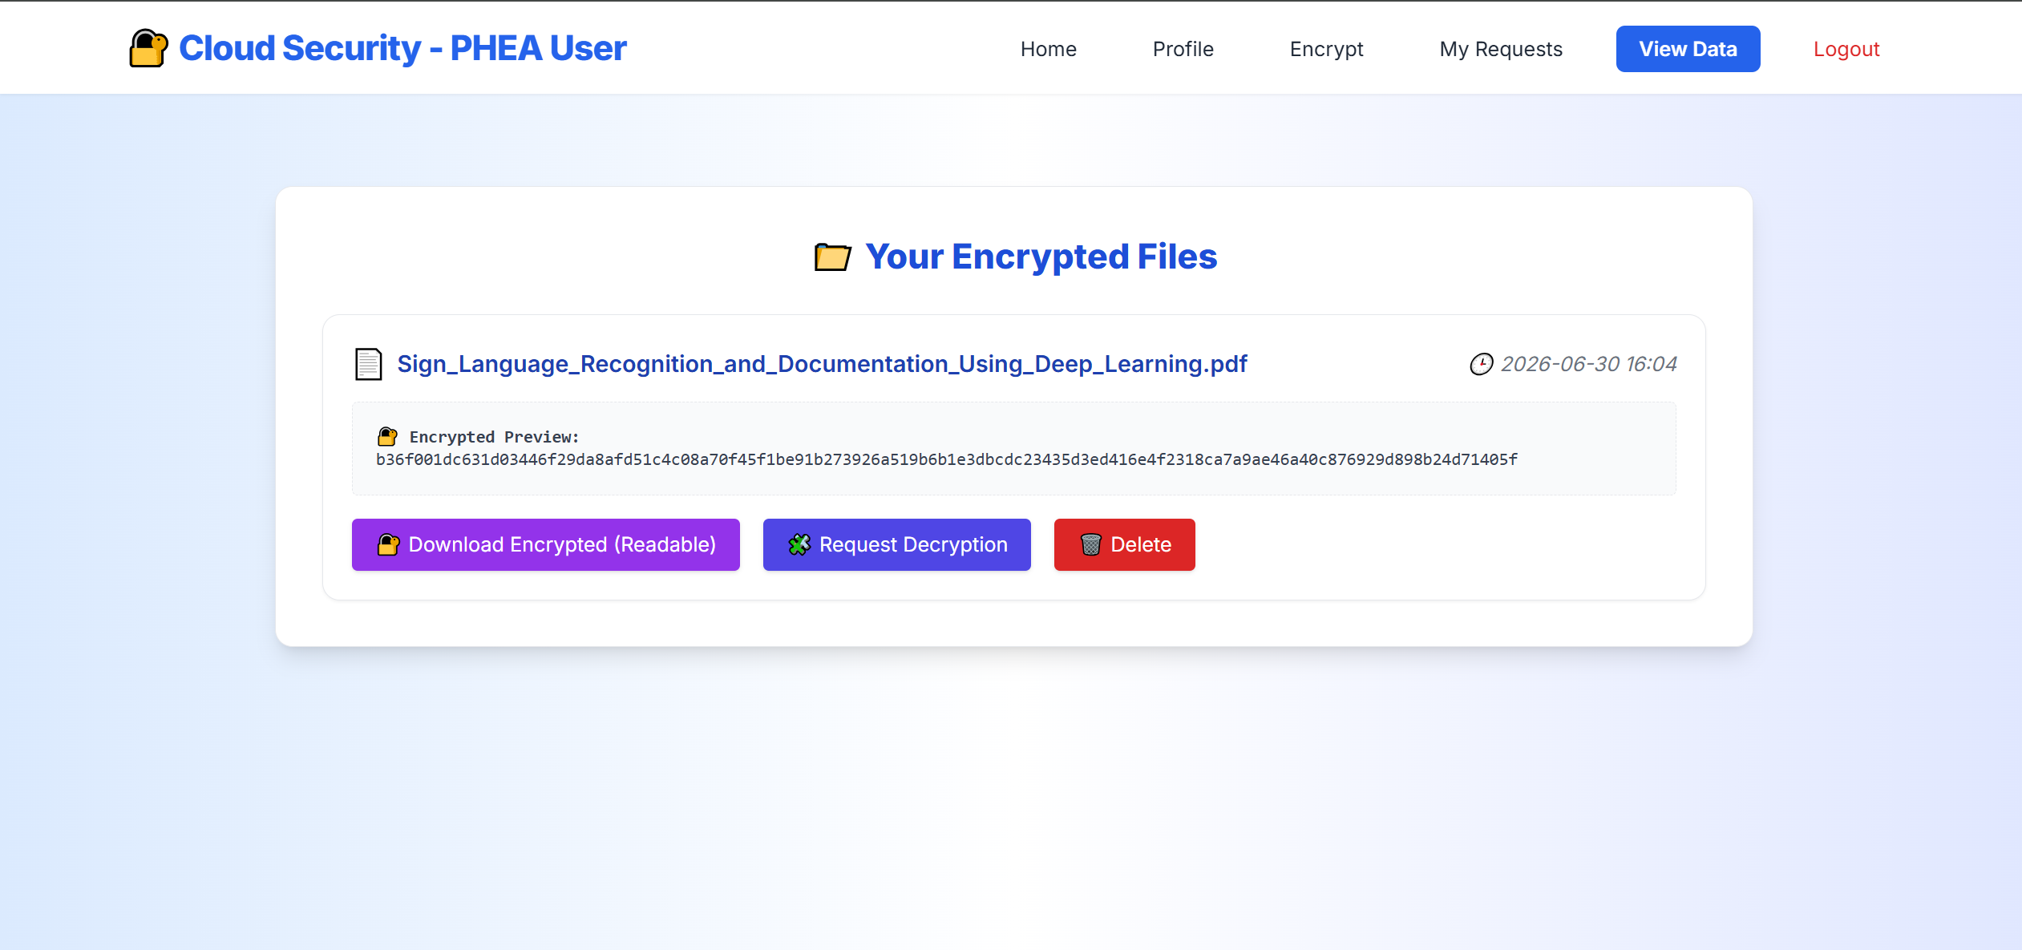Fig. 4. User View of Encrypted Data and Hex Preview Interface.

VII. CONCLUSION
This paper presented a hybrid cryptographic cloud storage framework that leverages AES-128-CBC for bulk file confidentiality and the Paillier Homomorphic Encryption Algorithm (PHEA) for secure key verification and additive computations. The system resolves the critical vulnerability of plaintext exposure during server-side processing.
Experimental evaluations yielded an encryption runtime of 19 ms and a decryption runtime of 35 ms for 5,000-byte payloads, confirming practical computational feasibility. By enforcing strict user lifecycle validation, single-use session encryption gating, and an administrator-approved decryption pipeline, the Django-based architecture delivers a comprehensive defense against unauthorized access and infrastructure compromise.
Future enhancements will focus on AI-based intrusion detection systems to automatically flag anomalous account behavior, time-based multi-factor authentication (TOTP) to strengthen operational security, and cloud object storage integration to scale payload persistence in distributed environments.
ACKNOWLEDGEMENT
The authors express sincere gratitude to the Management of Lords Institute of Engineering and Technology, Hyderabad, for providing the infrastructure and resources for this project. Special appreciation is extended to Mrs. B Nagalakshmi, Assistant Professor and internal guide, for her consistent mentorship. The authors also thank Dr. Ravi Kishore Singh, Principal, and Dr. K. Nagi Reddy, Professor and HOD, for their institutional support.
REFERENCES
[1] T. N. Kim and N. M. N. Pham, "Security-Performance Optimization in Cloud-Based Bank Data Processing Using HE-ZKP-ORAM," Engineering, Technology & Applied Science Research, vol. 16, no. 2, pp. 33760-33765, 2026.
[2] M. A. Junior, P. Appiahene, O. Appiah, and K. Adu, "Cloud Data Privacy Protection with Homomorphic Algorithm: A Systematic Literature Review," Journal of Cloud Computing, vol. 14, art. no. 84, 2025.
[3] Y. H. Chan et al., "HHEML: Hybrid Homomorphic Encryption for Privacy-Preserving Machine Learning on Edge," arXiv preprint arXiv:2510.20243, 2025.
[4] S. Serengil and A. Ozpinar, "Encrypted Vector Similarity Computations Using Partially Homomorphic Encryption: Applications and Performance Analysis," arXiv preprint arXiv:2503.05850, 2025.
[5] P. Paillier, "Public-Key Cryptosystems Based on Composite Degree Residuosity Classes," in Advances in Cryptology-EUROCRYPT '99, Lecture Notes in Computer Science, vol. 1592, pp. 223-238, Springer, 1999.
[6] A. Reyana et al., "Enhanced cloud storage encryption standard for security in distributed environments," Electronics, vol. 12, Art. no. 714, 2023.

